**To create the Web page and Header and Footer links in Apacheofbiz:**

1.open file🡪 \applications\shop\webapp\shop\WEB-INF\controller.xml

And then , add this field’s on top mapping area.

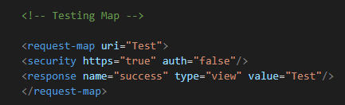

And then , add this field’s on top view area.

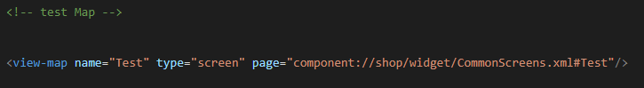

2.open file🡪 \applications\shop\widget\commonScreens.xml

And then , add this field’s

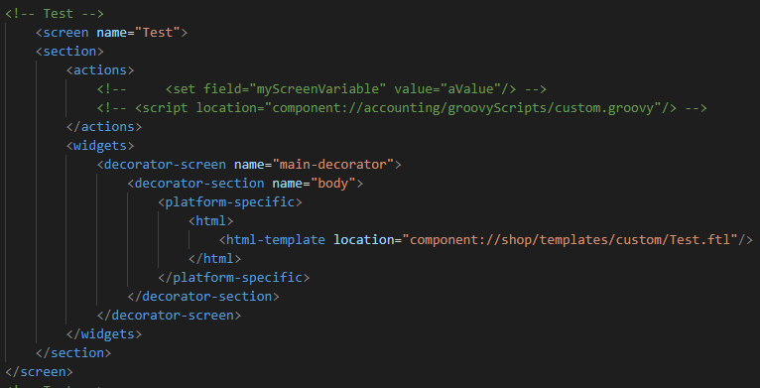

3.And then, create and “Test.ftl” file on \applications\shop\templates\custom\

And then, add this field on it

C:\Users\ONEDATA\Pictures\testFTL view.PNG

(you can write the html on it)

FINAL OUTPUT

Type on browser URL tab: https://localhost:8443/control/Test

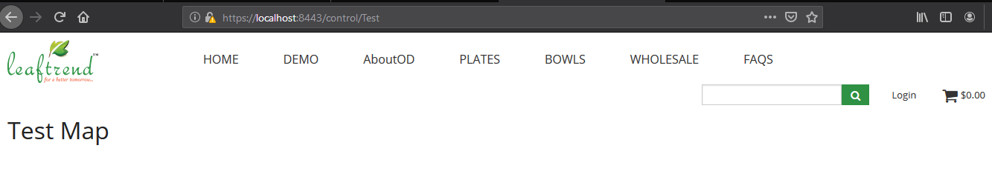

**TO GENERATE LING ON HEADER AND FOOTER**:

**HEADER:**

1.open file🡪 \themes\foundation-shop\includes\header.ftl

And then add the link on this page. 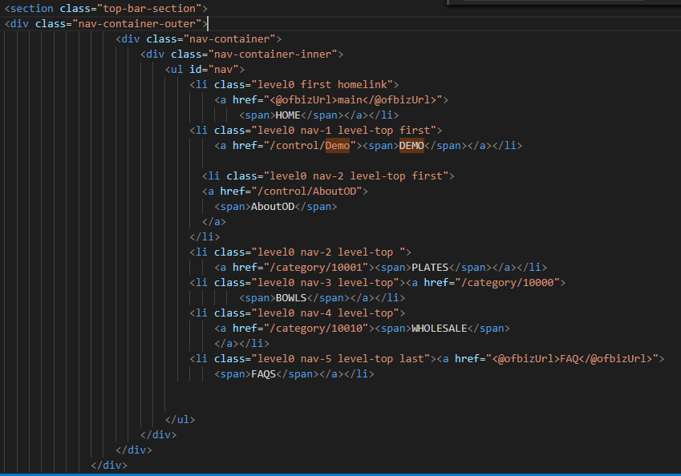

Open browser and then run <https://localhost:8443/control/>

The link will shown in the header tab(shown below)



**FOOTER:**

1.open file🡪 \themes\foundation-shop\includes\footer.ftl

And then add the link on this page.

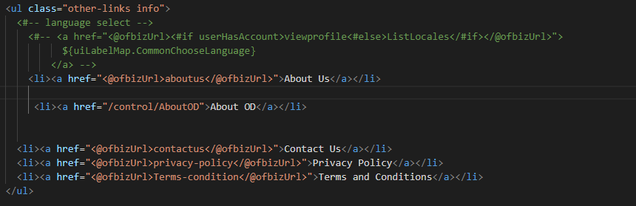

Open browser and then run <https://localhost:8443/control/>

The link will shown in the footer tab(shown below)

